**BT – 307**

**Assignment - 6**

**1)** Name – Milind Lakhwani Roll No – 200106046

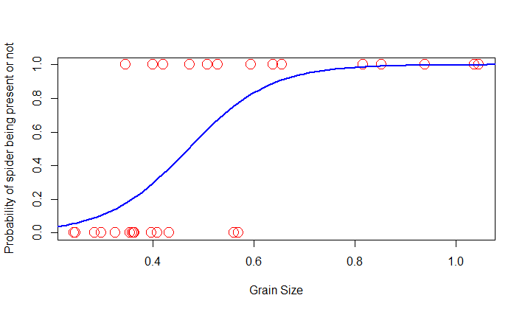**2)**

**3)**

P = 0.3

|  |  |  |
| --- | --- | --- |
|  | **Actual 0** | **Actual 1** |
| **Predicted 0** | 1 | **1** |
| **Predicted 1** | **6** | **6** |

P = 0.5

|  |  |  |
| --- | --- | --- |
|  | **Actual 0** | **Actual 1** |
| **Predicted 0** | **4** | **1** |
| **Predicted 1** | **3** | **6** |

P = 0.7

|  |  |  |
| --- | --- | --- |
|  | **Actual 0** | **Actual 1** |
| **Predicted 0** | **5** | **4** |
| **Predicted 1** | **2** | **3** |

**4) Bar Plot**